PRACTICAL NO : 1
AIM : Create a stand-alone application for performing login operation using core java concepts (Frame or Applets).

Code :
import java.applet.*;
import java.awt.*;
import java.awt.event.*;
/* <applet code="form.java" width=300 height=300></applet>*/
public class form extends Applet implements ActionListener {
String s1,s2,s3,s4,s5,s6,s7,s8,msg;
Label l1,l2,l3,l4,l5,l6,l7,l8;
Button b1;
Checkbox c1,c2,c3,c4,c5,c6;
CheckboxGroup g1,g2;
TextField t1,t2;
TextArea tr;
List l;
Choice ch1,ch2;
public void init() {
l1 =new Label("E.no");
l2 =new Label("Name");
l3 =new Label("Hostel");
l4 =new Label("Transport");
l5 =new Label("Club");
l6 =new Label("Collage"); l7 =new Label("Branch");
l8 =new Label("Subject"); b1 =new Button("Submit");
t1 =new TextField(12); t2 =new TextField(20);
g1 =new CheckboxGroup(); g2 =new CheckboxGroup();
c1 =new Checkbox("yes",g1,true); c2 =new Checkbox("NO",g1,false);
c3 =new Checkbox("Yes",g2,true); c4 =new Checkbox("No",g2,false);
c5 =new Checkbox("health"); c6 =new Checkbox("Library");
tr =new TextArea(); l =new List();
l.add("PIET"); l.add("PIT");
ch1=new Choice(); ch1.add("CSE");
ch1.add("IT"); ch1.add("civil");
ch1.add("electrical"); ch2=new Choice();
ch2.add("java"); ch2.add("c++");
ch2.add("applied electronics"); ch2.add("MOS");
add(l1); add(t1);
add(l2); add(t2);
add(l3); add(c1);
add(c2); add(l4);
add(c3); add(c4);
add(l5); add(c5);
add(c6); add(l6);
add(l); add(l7);
add(ch1); add(l8);
add(ch2); add(b1);
add(tr); b1.addActionListener(this);
}
public void actionPerformed(ActionEvent e) {
s1=t1.getText(); s2=t2.getText();
s3=g1.getSelectedCheckbox().getLabel(); s4=g2.getSelectedCheckbox().getLabel();
if(c5.getState()==true){
s5=c5.getLabel();
}else{
s5=c6.getLabel();
s6=l.getSelectedItem();
s7=ch1.getSelectedItem();
s8=ch2.getSelectedItem();
msg= "Student Name is :"+s2+"\nEnrollment No is :"+s1+"\nhostel :"+s3+
"\ntransport :"+s4+"\nmember of :"+s5+
"club \ncollege is :"+s6+"\nbranch selected is :"+s7+
"\nsubject :"+s8;
tr.setText(msg); } }

Output:
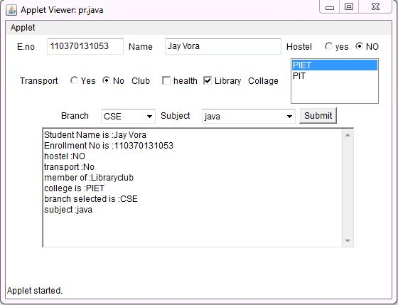

PRACTICAL NO : 2
AIM: Create a stand-alone application for registering of a student in a project using Swing GUI components.
Code:
package test;
import java.awt.Color;
import javax.swing.*;
import java.lang.reflect.InvocationTargetException;
/*< applet code="form.java" height =200 width=300 >*/
public class form extends javax.swing.JApplet {
public void init() {
try {
for (javax.swing.UIManager.LookAndFeelInfo info : javax.swing.UIManager.getInstalledLookAndFeels()) {
if ("Nimbus".equals(info.getName())) {
javax.swing.UIManager.setLookAndFeel(info.getClassName());
break; }
} } catch (Exception e) {
System.out.println(e.getMessage());
}
try {
java.awt.EventQueue.invokeAndWait(new Runnable() {
public void run() {
initComponents(); }
}); } catch (InterruptedException | InvocationTargetException ex) {
}
getContentPane().setBackground(Color.cyan);
}
private void initComponents() {
jScrollPane1 = new javax.swing.JScrollPane();
jTextArea1 = new javax.swing.JTextArea();
jLabel1 = new javax.swing.JLabel();
jTextField1 = new javax.swing.JTextField();
jButton1 = new javax.swing.JButton();
jScrollPane2 = new javax.swing.JScrollPane();
jTextArea2 = new javax.swing.JTextArea();
jLabel2 = new javax.swing.JLabel();
jLabel3 = new javax.swing.JLabel();
jLabel4 = new javax.swing.JLabel();
jLabel5 = new javax.swing.JLabel();
jLabel6 = new javax.swing.JLabel();
jLabel7 = new javax.swing.JLabel();
jLabel8 = new javax.swing.JLabel();
jTextField2 = new javax.swing.JTextField();
jRadioButton1 = new javax.swing.JRadioButton();
jRadioButton2 = new javax.swing.JRadioButton();
jRadioButton3 = new javax.swing.JRadioButton();
jRadioButton4 = new javax.swing.JRadioButton();
jCheckBox1 = new javax.swing.JCheckBox();
jCheckBox2 = new javax.swing.JCheckBox();
jComboBox1 = new javax.swing.JComboBox();
jComboBox2 = new javax.swing.JComboBox();
jScrollPane3 = new javax.swing.JScrollPane();
jList1 = new javax.swing.JList();
jTextArea1.setColumns(20);
jTextArea1.setRows(5);
jScrollPane1.setViewportView(jTextArea1);
setBackground(new java.awt.Color(153, 255, 255));
setForeground(new java.awt.Color(255, 255, 255));
jLabel1.setText("Name:");
jTextField1.addActionListener(new java.awt.event.ActionListener() {
public void actionPerformed(java.awt.event.ActionEventevt) {
jTextField1ActionPerformed(evt); }
}); jButton1.setText("Submit");
jButton1.addActionListener(new java.awt.event.ActionListener() {
public void actionPerformed(java.awt.event.ActionEventevt) {
jButton1ActionPerformed(evt); }
}); jTextArea2.setColumns(20);
jTextArea2.setRows(5);
jScrollPane2.setViewportView(jTextArea2);
jLabel2.setText("Enrollment no:");
jLabel3.setText("Hostel:");
jLabel4.setText("Transport:");
jLabel5.setText("Club:");
jLabel6.setText("Collage:");
jLabel7.setText("Branch:");
jLabel8.setText("Subject:");
jRadioButton1.setText("Yes");
jRadioButton1.addActionListener(new java.awt.event.ActionListener() {
public void actionPerformed(java.awt.event.ActionEventevt) {
jRadioButton1ActionPerformed(evt); }
}); jRadioButton2.setText("No");
jRadioButton2.addActionListener(new java.awt.event.ActionListener() {
public void actionPerformed(java.awt.event.ActionEventevt) {
jRadioButton2ActionPerformed(evt); }
}); jRadioButton3.setText("Yes");
jRadioButton4.setText("No");
jCheckBox1.setText("Health");
jCheckBox2.setText("Library");
jCheckBox2.addActionListener(new java.awt.event.ActionListener() {
public void actionPerformed(java.awt.event.ActionEventevt) {
jCheckBox2ActionPerformed(evt); }
}); jComboBox1.setModel(new javax.swing.DefaultComboBoxModel(new String[] { "PIET", "PIT" }));
jComboBox1.addActionListener(new java.awt.event.ActionListener() {
public void actionPerformed(java.awt.event.ActionEventevt) {
jComboBox1ActionPerformed(evt); }
}); jComboBox2.setModel(new javax.swing.DefaultComboBoxModel(new String[] { "CSE", "CIVIT", "ELECTRICAL", "EC", "MECHANICAL" }));
jList1.setModel(new javax.swing.AbstractListModel() {
String[] strings = { "C,C++", "JAVA", "AE", "MOS", "EEE" };
publicintgetSize() { return strings.length; }
public Object getElementAt(inti) { return strings[i]; }
});
jScrollPane3.setViewportView(jList1);
javax.swing.GroupLayout layout = new javax.swing.GroupLayout(getContentPane());
getContentPane().setLayout(layout);
layout.setHorizontalGroup(
layout.createParallelGroup(javax.swing.GroupLayout.Alignment.LEADING).addGroup(layout.createSequentialGroup() .addGroup(layout.createParallelGroup(javax.swing.GroupLayout.Alignment.LEADING)
.addGroup(layout.createSequentialGroup().addGap(30, 30, 30) .addGroup(layout.createParallelGroup(javax.swing.GroupLayout.Alignment.LEADING) .addGroup(javax.swing.GroupLayout.Alignment.TRAILING,.createSequentialGroup() .addGroup(layout.createParallelGroup(javax.swing.GroupLayout.Alignment.LEADING) .addComponent(jLabel1).addComponent(jLabel2)
.addComponent(jLabel3)
.addComponent(jLabel4))
.addGap(18, 18, 18))
.addGroup(layout.createSequentialGroup() .addGroup(layout.createParallelGroup(javax.swing.GroupLayout.Alignment.TRAILING)
.addComponent(jLabel7)
.addComponent(jLabel8) .addGroup(layout.createParallelGroup(javax.swing.GroupLayout.Alignment.LEADING)
.addComponent(jLabel5)
.addComponent(jLabel6)))
.addGap(18, 18, 18))) .addGroup(layout.createParallelGroup(javax.swing.GroupLayout.Alignment.LEADING)
.addGroup(layout.createSequentialGroup() .addComponent(jRadioButton3).addGap(18, 18, 18)
.addComponent(jRadioButton4))
.addGroup(layout.createSequentialGroup()
.addComponent(jRadioButton1)
.addGap(18, 18, 18) .addComponent(jRadioButton2)) .addGroup(layout.createParallelGroup(javax.swing.GroupLayout.Alignment.LEADING, false)
.addComponent(jTextField1, javax.swing.GroupLayout.DEFAULT_SIZE, 157, Short.MAX_VALUE)
.addComponent(jTextField2))
.addGroup(layout.createSequentialGroup()
.addComponent(jCheckBox1)
.addGap(18, 18, 18)
.addComponent(jCheckBox2))
.addComponent(jComboBox1, javax.swing.GroupLayout.PREFERRED_SIZE, javax.swing.GroupLayout.DEFAULT_SIZE, javax.swing.GroupLayout.PREFERRED_SIZE)
.addComponent(jComboBox2, javax.swing.GroupLayout.PREFERRED_SIZE, javax.swing.GroupLayout.DEFAULT_SIZE, javax.swing.GroupLayout.PREFERRED_SIZE)
.addComponent(jScrollPane3, javax.swing.GroupLayout.PREFERRED_SIZE, 56, javax.swing.GroupLayout.PREFERRED_SIZE)))
.addGroup(layout.createSequentialGroup()
.addGap(61, 61, 61)
.addComponent(jScrollPane2, javax.swing.GroupLayout.PREFERRED_SIZE, 202, javax.swing.GroupLayout.PREFERRED_SIZE))
.addGroup(javax.swing.GroupLayout.Alignment.TRAILING, layout.createSequentialGroup()
.addContainerGap()
.addComponent(jButton1)
.addGap(101, 101, 101)))
.addContainerGap(javax.swing.GroupLayout.DEFAULT_SIZE, Short.MAX_VALUE))
);
layout.setVerticalGroup(
layout.createParallelGroup(javax.swing.GroupLayout.Alignment.LEADING)
.addGroup(layout.createSequentialGroup()
.addContainerGap() .addGroup(layout.createParallelGroup(javax.swing.GroupLayout.Alignment.LEADING)
.addComponent(jTextField1, javax.swing.GroupLayout.PREFERRED_SIZE, javax.swing.GroupLayout.DEFAULT_SIZE, javax.swing.GroupLayout.PREFERRED_SIZE)
.addComponent(jLabel1))
.addPreferredGap(javax.swing.LayoutStyle.ComponentPlacement.UNRELATED)
.addGroup(layout.createParallelGroup(javax.swing.GroupLayout.Alignment.LEADING)
.addComponent(jLabel2)
.addComponent(jTextField2, javax.swing.GroupLayout.PREFERRED_SIZE, javax.swing.GroupLayout.DEFAULT_SIZE, javax.swing.GroupLayout.PREFERRED_SIZE))
.addPreferredGap(javax.swing.LayoutStyle.ComponentPlacement.RELATED)
.addGroup(layout.createParallelGroup(javax.swing.GroupLayout.Alignment.LEADING)
.addComponent(jLabel3)
.addGroup(layout.createParallelGroup(javax.swing.GroupLayout.Alignment.BASELINE)
.addComponent(jRadioButton1)
.addComponent(jRadioButton2)))
.addPreferredGap(javax.swing.LayoutStyle.ComponentPlacement.UNRELATED)
.addGroup(layout.createParallelGroup(javax.swing.GroupLayout.Alignment.LEADING)
.addComponent(jLabel4)
.addGroup(layout.createParallelGroup(javax.swing.GroupLayout.Alignment.BASELINE)
.addComponent(jRadioButton3)
.addComponent(jRadioButton4)))
.addPreferredGap(javax.swing.LayoutStyle.ComponentPlacement.UNRELATED)
.addGroup(layout.createParallelGroup(javax.swing.GroupLayout.Alignment.BASELINE)
.addComponent(jLabel5)
.addComponent(jCheckBox1)
.addComponent(jCheckBox2))
.addPreferredGap(javax.swing.LayoutStyle.ComponentPlacement.UNRELATED)
.addGroup(layout.createParallelGroup(javax.swing.GroupLayout.Alignment.BASELINE)
.addComponent(jLabel6)
.addComponent(jComboBox1, javax.swing.GroupLayout.PREFERRED_SIZE, javax.swing.GroupLayout.DEFAULT_SIZE, javax.swing.GroupLayout.PREFERRED_SIZE))
.addPreferredGap(javax.swing.LayoutStyle.ComponentPlacement.UNRELATED)
.addGroup(layout.createParallelGroup(javax.swing.GroupLayout.Alignment.LEADING)
.addComponent(jLabel7)
.addComponent(jComboBox2, javax.swing.GroupLayout.PREFERRED_SIZE, javax.swing.GroupLayout.DEFAULT_SIZE, javax.swing.GroupLayout.PREFERRED_SIZE))
.addPreferredGap(javax.swing.LayoutStyle.ComponentPlacement.UNRELATED)
.addGroup(layout.createParallelGroup(javax.swing.GroupLayout.Alignment.LEADING)
.addComponent(jLabel8)
.addComponent(jScrollPane3, javax.swing.GroupLayout.PREFERRED_SIZE, 87, javax.swing.GroupLayout.PREFERRED_SIZE))
.addPreferredGap(javax.swing.LayoutStyle.ComponentPlacement.UNRELATED)
.addComponent(jButton1)
.addPreferredGap(javax.swing.LayoutStyle.ComponentPlacement.UNRELATED)
.addComponent(jScrollPane2, javax.swing.GroupLayout.PREFERRED_SIZE, 148, javax.swing.GroupLayout.PREFERRED_SIZE)
.addContainerGap(javax.swing.GroupLayout.DEFAULT_SIZE, Short.MAX_VALUE))
);
}// </editor-fold>
private void jTextField1ActionPerformed(java.awt.event.ActionEventevt) {
// TODO add your handling code here:
}
private void jButton1ActionPerformed(java.awt.event.ActionEventevt) {
// TODO add your handling code here:=
String s1,s2,s3,s4,s5,s6,s7,s8;
s1=jTextField1.getText();
s2=jTextField2.getText();
if(jRadioButton1.isSelected()) {
s3="you selected hostel"; } else {
s3="you did not select hostel"; } if(jRadioButton3.isSelected()) {
s4="you selected transport"; } else {
s4="you did not select transport"; }
if(jCheckBox1.isSelected()) {
s5="you selected library";
} else {
s5="you selected Health";
} s6=(String)jComboBox1.getSelectedItem();
s7=(String)jComboBox2.getSelectedItem();
s8=(String)jList1.getSelectedValue();
jTextArea2.setText("Name:"+s1+"\n"+"Enrollment:"+s2+"\n"+s3+"\n"+s4+"\n"+s5+"\n"+s6+"\n"+s7+"\n"+s8);
} private void jRadioButton1ActionPerformed(java.awt.event.ActionEventevt) {
// TODO add your handling code here:
} private void jRadioButton2ActionPerformed(java.awt.event.ActionEventevt) {
// TODO add your handling code here:
} private void jCheckBox2ActionPerformed(java.awt.event.ActionEventevt) {
// TODO add your handling code here:
}
private void jComboBox1ActionPerformed(java.awt.event.ActionEventevt) {
// TODO add your handling code here:
}
// End of variables declaration
}

Output:

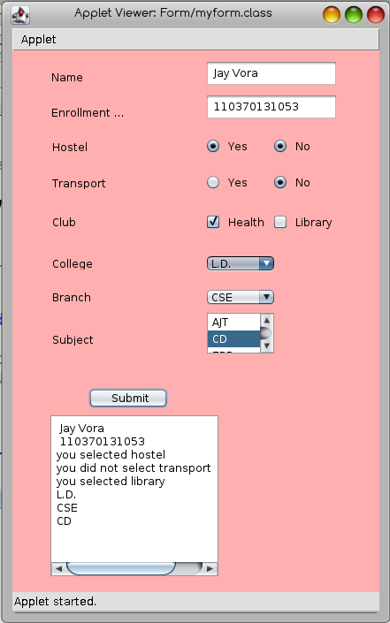

PRACTICAL NO: 3
AIM: Write a program using JDBC API to insert and retrieve data from the database.
Code :
import java.sql.*;
import java.util.*;
public class pra3 {
public static void main(String args[]) throws Exception {
Connection con=null;
Statement stmt=null;
ResultSet rs=null;
Scanner sc=new Scanner(System.in);
String usrname,usrpass,gun=null,gup=null;
Class.forName("com.mysql.jdbc.Driver");
System.out.println("Driver loaded.");
con=DriverManager.getConnection("jdbc:mysql://localhost/lab","root","java");
System.out.println("Connection Created..");
stmt=con.createStatement();
System.out.println("Wraper created...");
System.out.println("Enter user name: ");
usrname=sc.next();
System.out.println("Enter password: ");
usrpass=sc.next();
rs = stmt.executeQuery("SELECT * FROM employee WHERE NAME='"+usrname+"'");
if(rs.next()==false) {
System.out.println("New User Entry is Created!");
stmt.executeUpdate("INSERT into employee values('"+usrname+"','"+usrpass+"')");
} else {
String print = rs.getString("PASSWORD");
if(print.equals(usrpass)) {
System.out.println("Welcome " + usrname + "\t your account is deleted");
stmt.executeUpdate("DELETE FROM employee WHERE NAME='"+usrname+"'");
} else {
System.out.println("Invalid password!!! \t password is updated");
stmt.executeUpdate("UPDATE employee set PASSWORD='"+usrpass+"' where NAME='"+usrname+"'");
} } }
}
Output:
Driver loaded.
Connection Created..
Wraper created...
Enter user name:
jv
Enter password:
hello
Welcome jv your account is delete

PRACTICAL NO : 4
AIM: Write a program using JDBC API to update and delete data from the database using Prepared Statement.
Code:
package lab.clg;
import java.sql.*;
import java.util.Scanner;
public class pra3 {
static Connection con;
static PreparedStatement pstmt;
static Statement stmt;
public static void connectdb() throws ClassNotFoundException, SQLException {
String url="jdbc:mysql://localhost/lab";
String un="root";
String up="java";
Class.forName("com.mysql.jdbc.Driver");
System.out.println("Driver loaded.");
con=DriverManager.getConnection(url,un,up);
System.out.println("Connection Created..");
pstmt=con.prepareStatement("insert into employee values(?,?);" );
stmt=con.createStatement();
}
public static void main(String args[]) throws SQLException, ClassNotFoundException {
Scanner scan = new Scanner(System.in);
connectdb();
System.out.println("Enter 3 records in username password format : ");
for(int i=1;i<=3;i++) {
pstmt.setString(1, scan.next());
pstmt.setString(2, scan.next());
pstmt.executeUpdate();
}
ResultSet rs = stmt.executeQuery("select * from employee");
System.out.println("The records inserted are : ");
while(rs.next()) {
System.out.println("The user name is : " + rs.getString(1)+ " and password is : " + rs.getString(2)+ "..!");
}
}
}
Output :

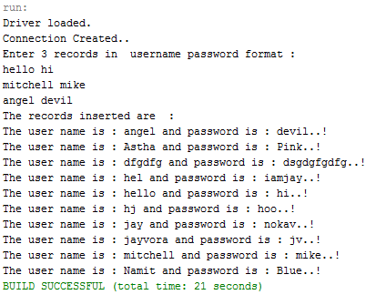
PRACTICAL NO:5
AIM: Write a server Socket Programming for connection oriented in which Client send the message to the Server and Server replay reverse message to the Client.
Server Code:
import java.net.*;
import java.io.*;
class server{
public static void main(String arg[] ) throws Exception{
ServerSocket s=new ServerSocket (8081);
System.out.println("waiting....");
Socket s2= s.accept();
PrintStream p1=new PrintStream (s2.getOutputStream());
BufferedReader r1=new BufferedReader(new InputStreamReader(s2.getInputStream()));
String c = r1.readLine();
//System.out.println(c);
p1.println(c);
p1.println("hie...");
r1.close();
p1.close();
s2.close();
s.close();
}
}

Client Code:

import java.net.*;
import java.io.*;
class client
{
public static void main(String arg[] ) throws Exception
{
Socket s1= new Socket ("localhost" ,8081);
PrintStream p= new PrintStream (s1.getOutputStream());

BufferedReader b1= new BufferedReader(new InputStreamReader(System.in));
BufferedReader b2= new BufferedReader(new InputStreamReader(s1.getInputStream()));
System.out.println("Enter string");
String a=b1.readLine();
p.println(a);
String b=b2.readLine();
System.out.println(“This is return from Server Side:- ”+b);
b2.close();
b1.close();
p.close();
s1.close();
}
}

Output:

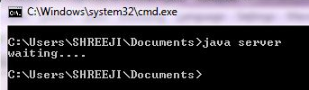

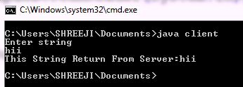
PRACTICAL NO:6
AIM: Write a RMI application to read content of a file on Server and send length of file to the Server.
Server Code:
Adder.java:
importjava.rmi.*;
public interface Adder extends Remote{
public String fo(String f)throws RemoteException;
}
AdderRemote.java:
importjava.rmi.*;
importjava.rmi.server.*;
public class AdderRemote extends UnicastRemoteObject implements Adder{
AdderRemote()throws RemoteException{
super();
}
public String fo(String f){
return f;
}}
MyServer.java:
importjava.rmi.*;
importjava.rmi.registry.*;
public class MyServer{
public static void main(String args[]){
try{
Adder stub=new AdderRemote();
Naming.rebind("rmi://localhost:5000/sonoo",stub);
}catch(Exception e){System.out.println(e);}
}
}
Client Code:
Adder.java:
importjava.rmi.*;
public interface Adder extends Remote{
public String fo(String f)throws RemoteException;
}
MyClient.java:
importjava.rmi.*;
import java.io.*;
importjava.nio.*;
importjava.nio.channels.*;
public class MyClient{
public static void main(String args[]){
FileInputStreamfIn;
FileChannelfChan;
longfSize;
ByteBuffermBuf;
try{
Adder stub=(Adder)Naming.lookup("rmi://localhost:5000/sonoo");
fIn = new FileInputStream("Hello.txt");
fChan = fIn.getChannel();
fSize = fChan.size();
mBuf = ByteBuffer.allocate((int)fSize);
fChan.read(mBuf);
mBuf.rewind();
for(inti=0; i<fSize; i++)
System.out.print((char)mBuf.get());
System.out.println();
System.out.println(fSize);
fChan.close(); // close channel
fIn.close(); // close file
} catch(Exception e){System.out.println(e);
System.exit(1);
}}}

Output:
Console : Client Output:
>javac Adder.java > java MyClient
>javac AdderRemote.java >hello hie…Im Jay
>javac MyServer.java
>start rmiregistry 5000
>start java MyServer

PRACTICAL NO:7
AIM: Create a web application that shows the use of session management and context in Servlets.

Code:
import java.io.*;
import javax.servlet.*;
import javax.servlet.http.*;
import java.sql.*;
import java.util.*;
public class sessionlogin extends HttpServlet {
Connection con=null;
Statement stmt=null;
ResultSet rs=null;
String n,p;
boolean flag1=false, flag2=false;
public void init(ServletConfig sc)throws ServletException{
super.init(sc);
try{
Class.forName("com.mysql.jdbc.Driver");
con=DriverManager.getConnection("jdbc:mysql://localhost:3306/lab",”root”,”java”);
stmt=con.createStatement();
rs=stmt.executeQuery("select * from employee");
} catch(Exception e) {
System.out.println(e.getMessage());
} }
public void doGet(HttpServletRequest req,HttpServletResponse res)throws ServletException,IOException {
res.setContentType("text/html");
PrintWriter out=res.getWriter();
doPost(req,res);
}
public void doPost(HttpServletRequest req,HttpServletResponse res)throws ServletException,IOException{
res.setContentType("text/html");
PrintWriter out=res.getWriter();
if(req.getParameter("btnsub")!=null) {
try{
while(rs.next()){
n=rs.getString("name");
p=rs.getString("password");
if(n.equals(req.getParameter("txtname"))){
flag1=true;
if(p.equals(req.getParameter("txtpass"))){
flag2=true;
break;
}
} }
if(flag1 && flag2) {
HttpSession hs=req.getSession(true);
hs.setMaxInactiveInterval(30);
hs.setAttribute("un", req.getParameter("txtname"));
res.sendRedirect("productselection");
}else{
out.println("Wrong password");
}
}catch(Exception e) { out.println(e.getMessage());
} }
out.println("<html><body><form method='post' action='sessionlogin'>");
out.println("UserName:<input type='text' name='txtname'>");
out.println("Password:<input type='text' name='txtpass'>");
out.println("<input type='submit' name='btnsub' value='Submit'>");
out.println("</form></body></html>");
} }
Output :
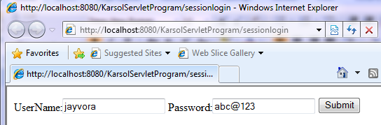
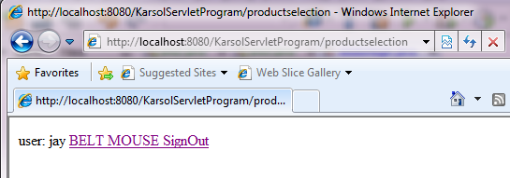

PRACTICAL NO : 8
AIM: Create a web application that shows the use of cookies.

Code:
import java.io.*;
import javax.servlet.http.*;
public class showcookie extends HttpServlet {
public void doGet(HttpServletRequest req,HttpServletResponse res) throws IOException{
res.setContentType("Text/html");
PrintWriter out=res.getWriter();
doPost(req,res);
}
public void doPost(HttpServletRequest req,HttpServletResponse res) throws IOException{
res.setContentType("Text/html");
PrintWriter out=res.getWriter();
Cookie n=new Cookie("txtname","jv");
res.addCookie(n);
Cookie p=new Cookie("txtpass","1218");
res.addCookie(p);
Cookie q=new Cookie("Qualification","B.E.");
q.setMaxAge(1*60*60);
res.addCookie(q);
Cookie add=new Cookie("Address","Rib");
q.setMaxAge(1*60*60);
res.addCookie(add);
Cookie c[]=req.getCookies();
String x="",y="";
if(req.getParameter("all")!=null) {
out.print("<html><body>");
out.print("<table border='1'>");
out.print("<th> Name </th> <th> Value </th>");
for(int i=0;i<c.length;i++){
out.print("<tr>");
out.print("<td>"+c[i].getName()+"</td>");
out.print("<td>"+c[i].getValue()+"</td>");
out.print("</tr>");
}
out.print("</table></body></html>");
}
if(req.getParameter("first")!=null) {
x=c[0].getName();
y=c[0].getValue();
} if(req.getParameter("last")!=null) {
int u=c.length-1;
x=c[u].getName();
y=c[u].getValue();
}
if(req.getParameter("add")!=null){
Cookie nv=new Cookie(req.getParameter("tname"),req.getParameter("tpass"));
res.addCookie(nv);
}
if(req.getParameter("delete")!=null){
Cookie dc=new Cookie(req.getParameter("tname"),req.getParameter("tpass"));
dc.setMaxAge(0);
res.addCookie(dc);
}
if(req.getParameter("previous")!=null) {
try {
String pn=req.getParameter("tname");
String pp=req.getParameter("tpass");
for(int i=0;i<c.length;i++){
if(c[i].getName().equals(pn)) {
x=c[i-1].getName();
y=c[i-1].getValue();
} }
}catch(Exception e){
out.print("No Previous data!!!");
}
}
if(req.getParameter("next")!=null)
{ try{
String nn=req.getParameter("tname");
String np=req.getParameter("tpass");
for(int i=0;i<c.length;i++){
if(c[i].getName().equals(nn)) {
x=c[i+1].getName();
y=c[i+1].getValue();
}
}
}catch(Exception e){
out.print("No Coockie awalable...");
}
}
out.print("<html><body>");
out.print("<form name=cookie method='get' action='showcookie'>");
out.print("Name: <input type='text' name='tname' value='"+x+"'>");
out.print("Pass: <input type='text' name='tpass' value='"+y+"'>");
out.print("<input type='submit' name='all' value='Show All'>");
out.print("<input type='submit' name='first' value='First'>");
out.print("<input type='submit' name='last' value='Last'>");
out.print("<input type='submit' name='add' value='ADD'>");
out.print("<input type='submit' name='delete' value='DELETE'>");
out.print("<input type='submit' name='previous' value='PREVIOUS'>");
out.print("<input type='submit' name='next' value='NEXT'>");
out.print("</form></body></html>");
}
}
Output :

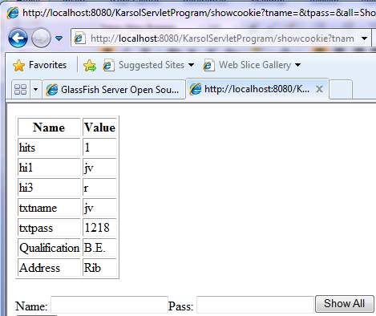

PRACTICAL NO : 9
AIM: Create a Web application that makes use of SQL Tag Library.

Code:
<%@ taglib uri=http://java.sun.com/jsp/jstl/core" prefix="c"%>
<%@ taglib uri=http://java.sun.com/jsp/jstl/sql" prefix="sql"%>
<html>
<head>
<title>JSTL SQL tAG App</title>
</head>
<body>

<sql:setDataSource var="DB" driver="com.mysql.jdbc.Driver"
url="jdbc:mysql://localhost/test"
user="root" password="mypassword"/>
<sql:query dataSource="${DB}" var="Rec">
SELECT * from Employee;
</sql:query>
<center>
<h2>Employee Database</h2>
<table border="1">
<tr>
<th>ID</th>
<th>Name</th>
<th>Age</th>
</tr>
<c:forEach var="row" items="${Rec.rows}">;
<tr>
<td><c:out value="${row.id}"></td>
<td><c:out value="${row.name}"></td>
<td><c:out value="${row.age}"></td>
</tr>
</c:forEach>
</table>
</center>
</body>
</html>

Output :

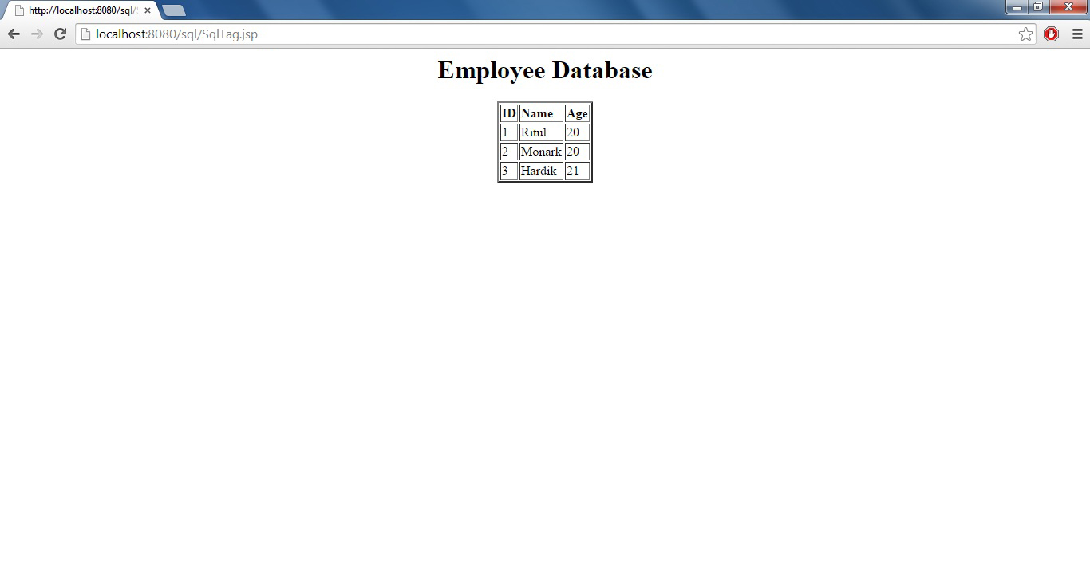
PRACTICAL NO : 10
AIM: Design a login page in JSP.
Code:
<%@page contentType="text/html" pageEncoding="UTF-8"%>
<html>
<head>
<meta http-equiv="Content-Type" content="text/html; charset=UTF-8">
<title>JSP Page</title>
</head>
<body>
<h1>Login Page</h1>
<center>
<h2>Signup Details</h2>
<form action="LoginCheck.jsp" method="post">
<br/>Username:<input type="text" name="username">
<br/>Password:<input type="password" name="password">
<br/><input type="submit" value="Submit">
</form>
</center>
</body>
</html>
LoginCheck.jsp: -
<%@page contentType="text/html" pageEncoding="UTF-8"%>
<html>
<head>
<meta http-equiv="Content-Type" content="text/html; charset=UTF-8">
<title>JSP Page</title>
</head>
<body>
<%
String username=request.getParameter("username");
String password=request.getParameter("password");
if((username.equals("jv") && password.equals("hello")))
{
session.setAttribute("username",username);
response.sendRedirect("Home.jsp");
}
else
response.sendRedirect("Error.jsp");
%>
</body>
</html>
Home.jsp: -
<%@page contentType="text/html" pageEncoding="UTF-8" errorPage="Error.jsp"%>

<head>
<meta http-equiv="Content-Type" content="text/html; charset=UTF-8">
<title>JSP Page</title>
</head>
<body>
<br/><br/><br/><br/><br/>
<center>
<h2>
<%
String a=session.getAttribute("username").toString();
out.println("Hello "+a);
%>
</h2>
<br/>
<br/>
<br/><br/><br/><br/><br/>
<a href="Logout.jsp">Logout</a>
</center>
</body>
</html>
Logout.jsp: -
<%@page contentType="text/html" pageEncoding="UTF-8"%>
<html>
<head>
<meta http-equiv="Content-Type" content="text/html; charset=UTF-8">
<title>JSP Page</title>
</head>
<body>
<%
session.removeAttribute("username");
session.removeAttribute("password");
session.invalidate();
%>
<h1>Logout was done successfully.</h1>
</body>
</html>
Error.jsp: -
<%@page contentType="text/html" pageEncoding="UTF-8"%>
<html>
<head>
<meta http-equiv="Content-Type" content="text/html; charset=UTF-8">
<title>JSP Page</title>
</head>
<body>
<h1>Some Error has occured,Please try again later...</h1>
</body>
</html>
Output: -

